Name:
Date:
15.07 Picture Lab Worksheet
Directions: Make note of your responses to the following questions as you work through the activities and exercise in the lesson.
Activity 5 Questions
Question | Yes | No
- Is the method getPixels2D in the Picture.java class? |  | T
- Is the method getPixels2D in the SimplePicture.java class? | T
- Will the following code compile?  DigitalPicture p = new DigitalPicture(); |  | T
- Assuming a no-argument constructor exists for SimplePicture, will the following code compile?  DigitalPicture p = new SimplePicture(); | T
- Assuming a no-argument constructor exists for Picture, will the following code compile?  DigitalPicture p = new Picture(); | T
- Assuming a no-argument constructor exists for Picture, will the following code compile?  SimplePicture p = new Picture(); | T
- Assuming a no-argument constructor exists for SimplePicture, will the following code compile?  Picture p = new SimplePicture(); |  | T

Activity 5 Exercise Results

- Describe your method for keepOnly red, blue, or green.
I chose to create a keepOnlyRed() method and the way I did this was by setting every blue and green pixel value to 0.
- For the negate method, paste your code related to calculating and setting the values for red, blue, and green.
imageArr[i][j].setRed(255 - imageArr[i][j].getRed());
imageArr[i][j].setGreen(255 - imageArr[i][j].getGreen());
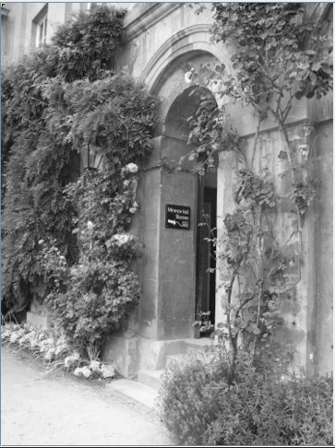
imageArr[i][j].setBlue(255 - imageArr[i][j].getBlue());
- Paste a copy of the image that is the result of calling the grayscale.

- For the method fixUnderwater, describe the algorithm you'd propose to accomplish the task.
If I were to approach this problem, I would look for pixels that have a blue value above a certain threshhold and make them darker, thereby increasing the contrast between the water and the fish.
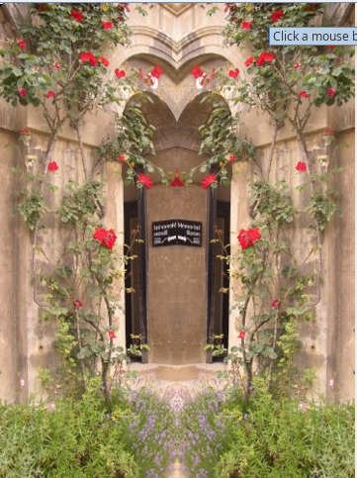
- Activity 6 Exercise ResultsPaste the image that is the result of calling the method mirrorVerticalRightToLeft.

- Describe the algorithm for the method mirrorHorizontal works.
The algorithm goes from the top of the image to the bottom and replaces the bottom pixel of focus to its corresponding top pixel.
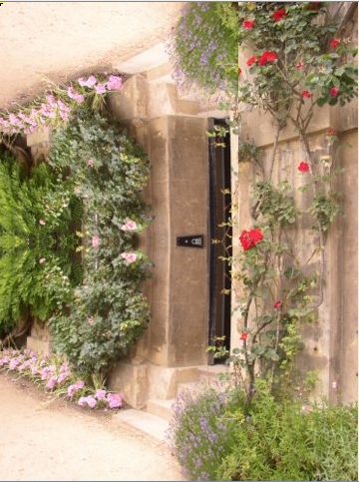
- Paste the image that is the result of calling the method mirrorHorizontalBotToTop.

Activity 7 Questions
  - How many times would the body of this nested for loop execute? 90
for(int row = 7; row < 17; row++)
for(int col = 6; col < 15; col++)
  - How many times would the body of this nested for loop execute? 112
for(int row = 5; row <= 11; row++)
for(int col = 3; col <= 18; col++)

Activity 7 Exercise Results

- What value is displayed for count after the nested loop ends in the mirrorTemple method? 18410
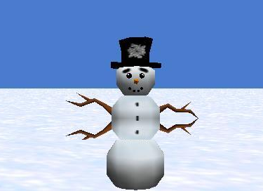
- Paste the image that is the result of calling the method mirrorArms.

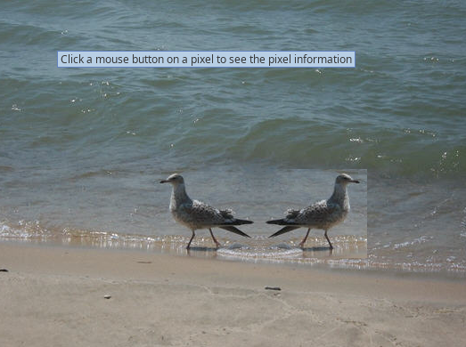
- Paste the image that is the result of calling the method mirrorGull.

